Automating and visualizing fire department data to inform management and operations
Seattle Fire has a large number of complex data sources from fire operations, EMS, dispatch, Medic One, training, and more. Until recently these data were highly siloed and difficult to access, much less cross-reference. The FireSTAT program and the data warehouse have dramatically changed that. The data warehouse – expertly built and administered by Seattle IT – provides a one-stop shop for a growing number of data sources, allowing easy analysis, visualization, and export. We are already seeing the benefits of this system as it reduces manual, repetitive data analysis and provides a window for department leadership into trends and hotspots.
- Jon Ehrenfeld, Mobile Integrated Health Program Manager
THE NEED  The Seattle Fire Department (SFD) had identified an opportunity to drive performance with own operational data, but faced a series of obstacles:  - Disparate and inaccessible data sets: Operational data was stored in thirteen unconnected data systems, in a wide variety of formats.  - Reporting tools that for worked for some, but not all: Many of SFD’s systems for monitoring and interrogating performance were static spreadsheets containing Department-level data. Many found them difficult to interpret; those who had narrower operational responsibilities often could not easily isolate the performance of their battalion or unit.  - Few opportunities to bring data to operational problem-solving: With few regular opportunities for Department-wide interrogation of operational measures, performance management often relied upon ad-hoc communications from leadership to operational groups.  OUR APPROACH  Innovation & Performance (IP) worked with SFD to design and build a program of data warehousing and performance management. The project delivered infrastructure - in the automation and transformation of key datasets across 13 disparate data sources maintained by the department - and interactive performance dashboards that allowed data to be interrogated from the department to unit-and shift-level staff.  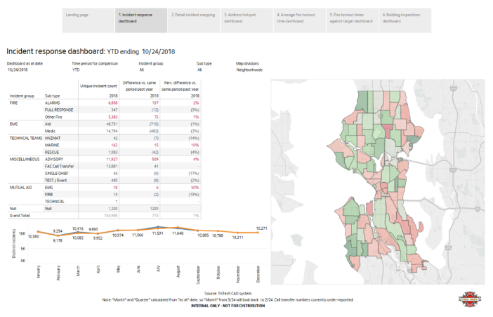  THE RESULTS  The project deepened the use of data and performance measures in by SFD management, with back-end automation and visualization allowing performance measures to be better-integrated into management. Not only did the work support collaborative problem solving around SFD’s key performance indicators, but the automation process has provided a platform for deeper data analysis and shared problem-solving around these issues. | DEPARTMENT PARTNERS  Seattle Fire Department  PROJECT  DURATION  January – June 2018  IMPACT  Enables SFD operational decision-makers to identify, analyze and respond to key trends in fire and EMS demand  KEY DEPARTMENT  CONTACTS  - Jon Ehrenfeld (SFD)  FOR MORE  INFORMATION  CONTACT  - Richard Todd (IP)  - Mike Wypyszinski (IP)

